**AGENCY POLICY**

TABLE CREATION

**TAB 1**: DASHBOARD

CREATE TABLE DASHBOARD(

TOTAL_POLICIES NUMBER(10),

PREMIUM NUMBER(10),

TODAY NUMBER(10),

MONTH NUMBER(10),

YEAR NUMBER(10));

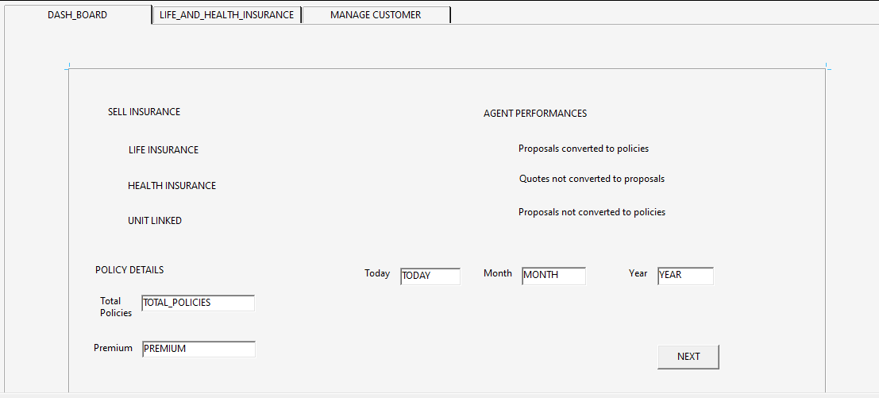

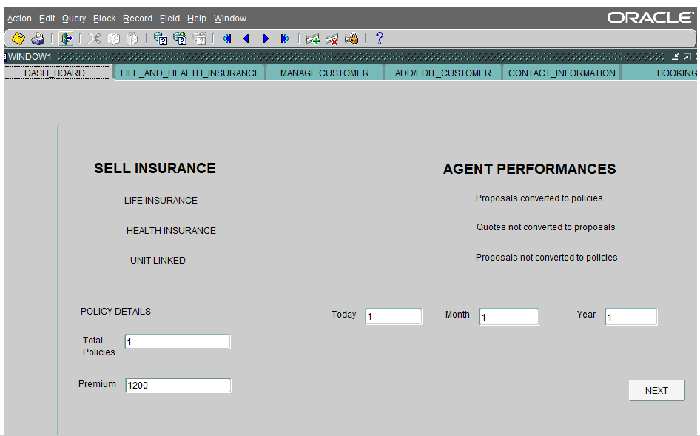

**TAB 2:** LIFE AND HEALTH INSURANCE

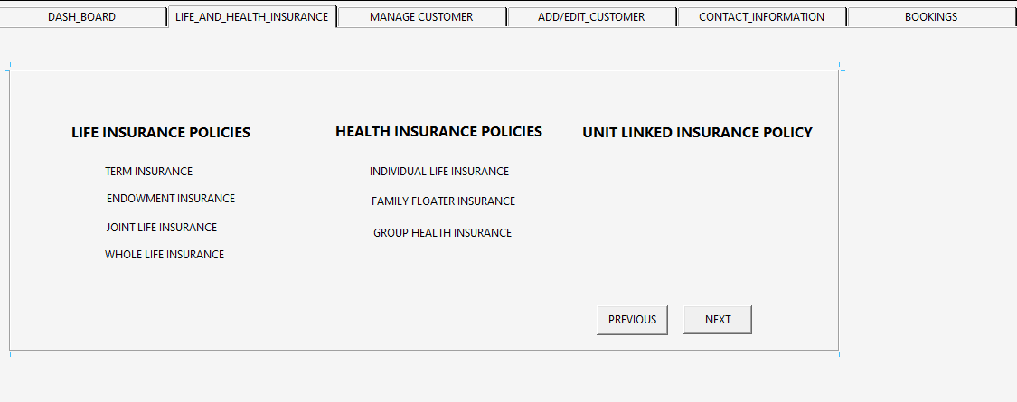

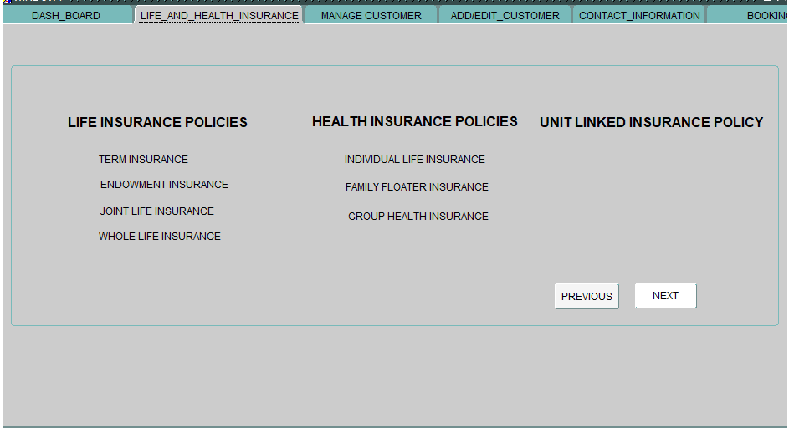

**TAB 3:** MANAGE CUSTOMER

CREATE TABLE MANAGE_CUSTOMER (SLNO NUMBER(10),

FULL_NAME VARCHAR2(20),

IDENTIFICATION VARCHAR2(30),

MOBILE_NUMBER NUMBER(10),

EMAIL_ID VARCHAR2(10),

ACTION VARCHAR2(10));

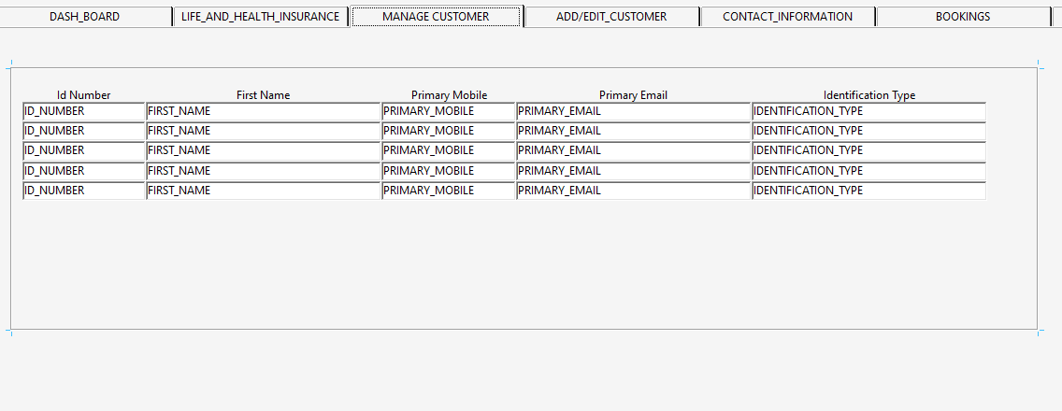

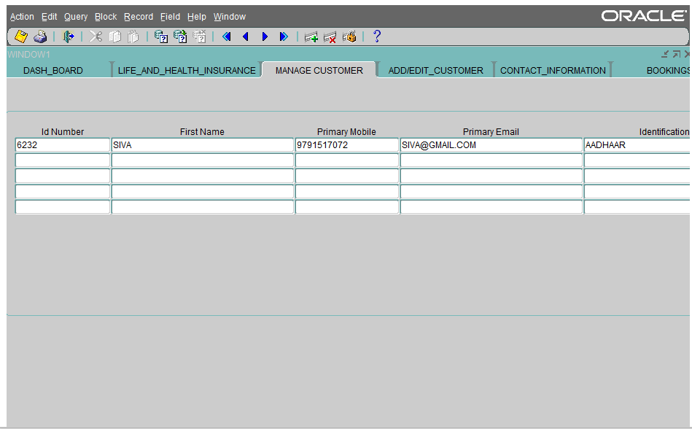

**TAB 4:** ADD/EDIT CUSTOMER

CREATE TABLE AGENT_CUSTOMER_DETAILS(

ID_NUMBER NUMBER,

FIRST_NAME VARCHAR2(20),

LAST_NAME VARCHAR2(10),

GENDER VARCHAR2(6),

DATE_OF_BIRTH DATE,

EDUCATION VARCHAR2(20),

INCOME NUMBER,

SMOKER VARCHAR2(10),

DRINKER VARCHAR2(10),

OCCUPATION VARCHAR2(20),

RELIGION VARCHAR2(10),

C_LOCATION VARCHAR2(20),

NATIONALITY VARCHAR2(10),

PINCODE NUMBER(6),

MARTIAL_STATUS VARCHAR2(20),

IDENTIFICATION_TYPE VARCHAR2(20),

PRIMARY_MOBILE NUMBER(10),

PRIMARY_EMAIL VARCHAR2(20));

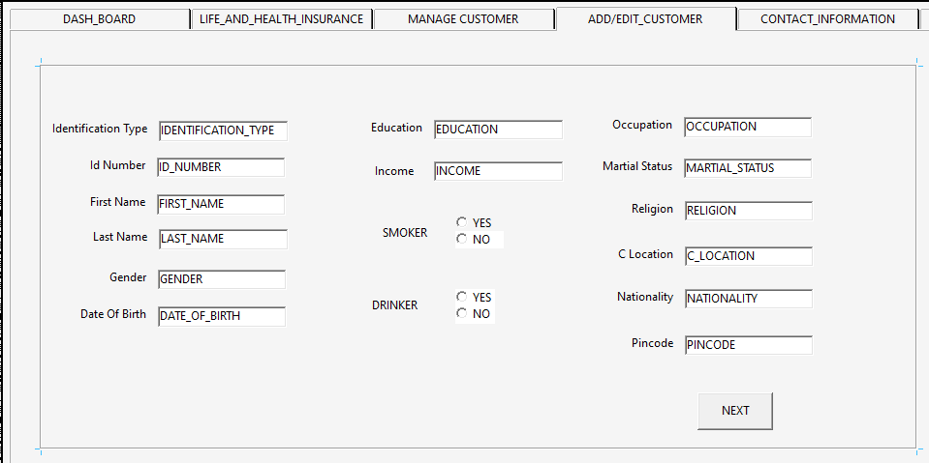

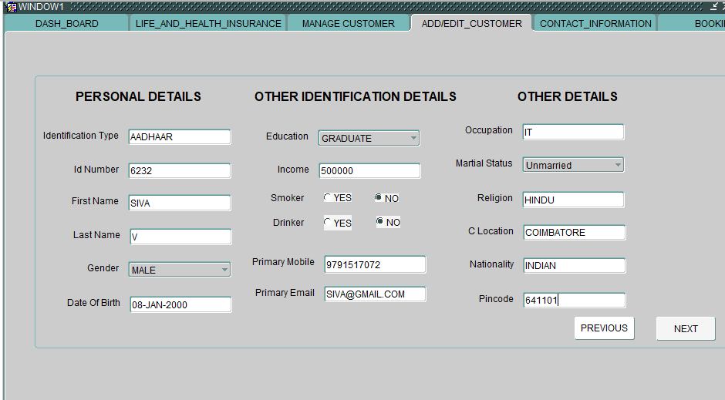

.

**TAB 5:** CONTACT_INFORMATION

CREATE TABLE CONTACT_INFORMATION(

HOME_TELEPHONE NUMBER(10),

ALTERNATE_MOBILE_NO NUMBER(10),

ALTERNATIVE_EMAIL VARCHAR2(20),

PR_ADDRESS1 VARCHAR2(100),

PR_ADDRESS2 VARCHAR2(100),

PR_COUNTRY VARCHAR2(20),

PR_STATE VARCHAR2(10),

PR_DIST VARCHAR2(20),

PR_VILLAGE VARCHAR2(20),

PM_ADDRESS1 VARCHAR2(100),

PM_ADDRESS2 VARCHAR2(100),

PM_COUNTRY VARCHAR2(20),

PM_STATE VARCHAR2(10),

PM_DIST VARCHAR2(20),

PM_VILLAGE VARCHAR2(20)

);

ALTER TABLE AGENT_CUSTOMER_DETAILS ADD MARTIAL_STATUS VARCHAR2(20);

ALTER TABLE AGENT_CUSTOMER_DETAILS ADD IDENTIFICATION_TYPE VARCHAR2(20);

DESC AGENT_CUSTOMER_DETAILS;

ALTER TABLE AGENT_CUSTOMER_DETAILS modify SMOKER VARCHAR2(10);

ALTER TABLE AGENT_CUSTOMER_DETAILS modify DRINKER VARCHAR2(10);

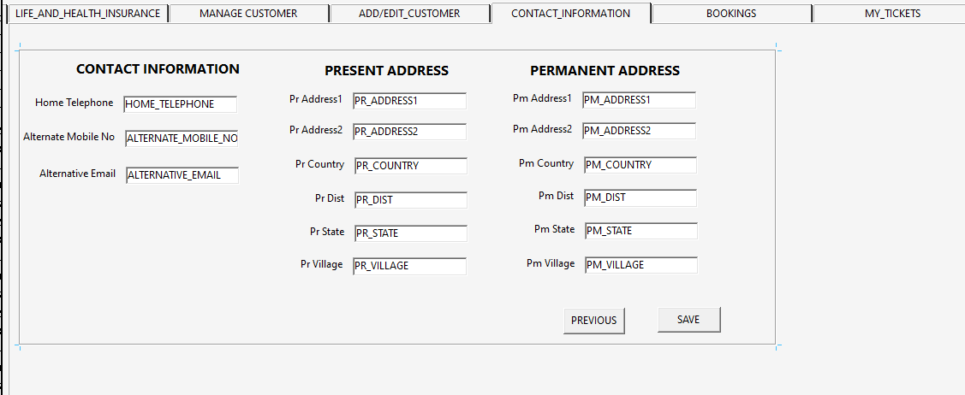

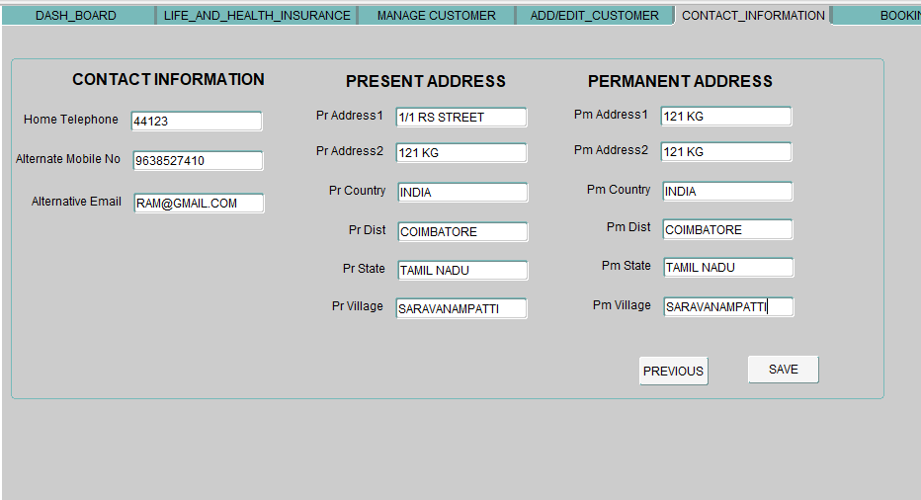

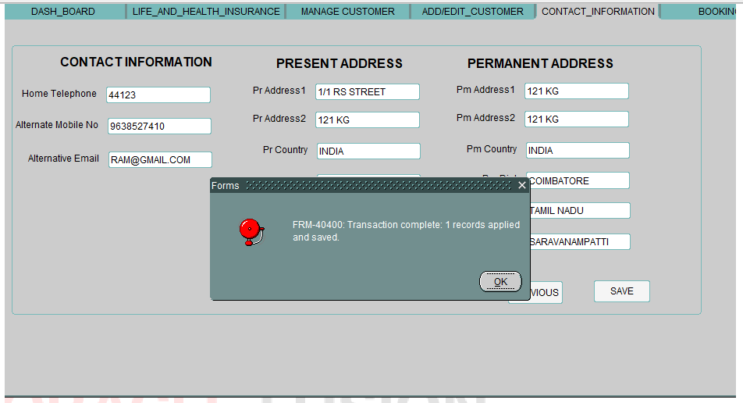

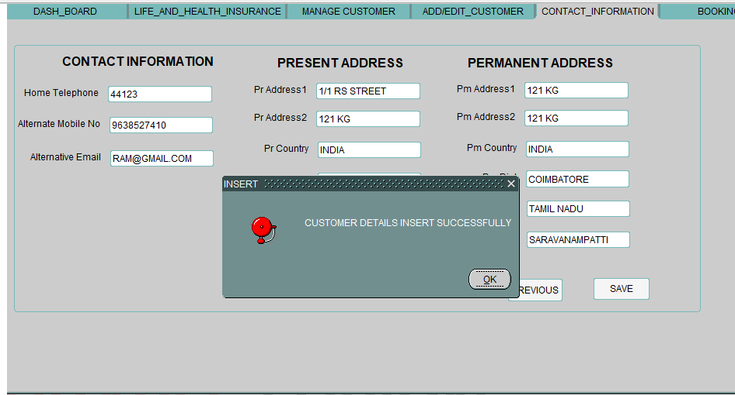

**TAB 6:** BOOKINGS

CREATE TABLE BOOKINGS(

ALL_PRODUCTS VARCHAR2(40),

FROM_DATE DATE,

TO_DATE_B DATE,

B_NAME VARCHAR2(30),

POLICY_ID VARCHAR2(20),

LEAD_ID VARCHAR2(20),

PREMIUM NUMBER(10),

BOOKED_ON DATE);

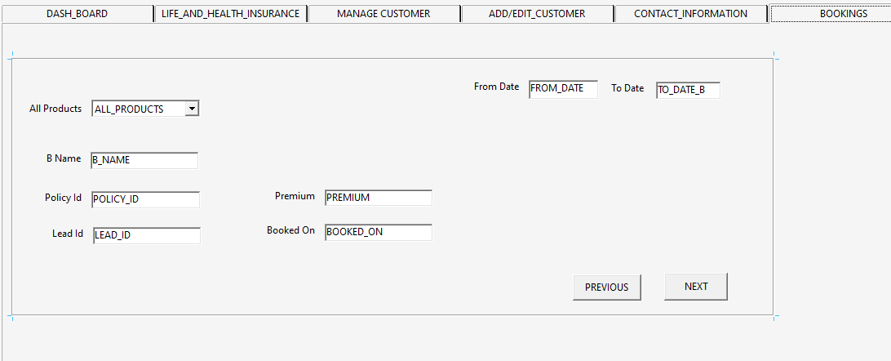

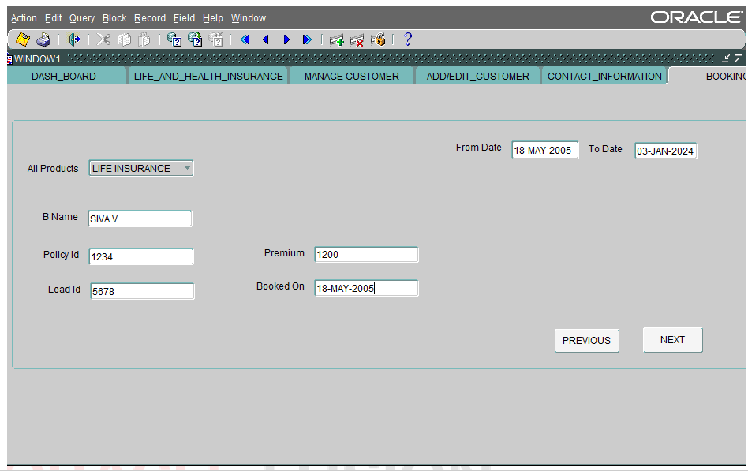

**TAB 7**: MY_TICKETS

CREATE TABLE MY_TICKETS(

FROM_DATE_MT DATE,

TO_DATE_MT DATE,

ALL_TICKETS VARCHAR2(20),

NEW_TICKETS VARCHAR2(20),

PROGRESSING VARCHAR2(20));

